**Lab Report. 08**

**Subject: Computer Graphics Lab**



Submitted to: Dr. Junaid

Submitted by: Nayab Ashraf (RC-299)

**Date of Submission: 11 November, 2024**

National University of Modern Languages, Department of Computer Science, Rawalpindi Campus.

**Task 01:**

**Write a program to implement the Bresehnams line drawing Algorithm.**

#include<windows.h>

#include <GL/gl.h>

#include <math.h>

#include <gl/glut.h>

void myInit()

{

glClearColor(1.0, 1.0, 1.0, 0.0);

glPointSize(10.0);

glMatrixMode(GL_MODELVIEW);

glLoadIdentity();

gluOrtho2D(0.0, 500.0, 0.0, 500.0);

}

void BDL(float x0, float y0, float xn, float yn)

{

float Deltax = (float)(xn - x0);

float Deltay = (float)(yn - y0);

float Pk = 2*Deltay - Deltax;

while (x0 != xn)

{

glBegin(GL_POINTS);

if (Pk < 0)

{

Pk = Pk + 2*Deltay;

x0 = x0 + 1;

y0 = y0;

}

else if (Pk >= 0)

{

Pk = Pk + 2*Deltay - 2*Deltax;

x0 = x0 + 1;

y0 = y0 + 1;

}

glVertex2f(x0, y0);

glVertex2f(xn, yn);

glEnd();

}

}

void Display()

{

glClear(GL_COLOR_BUFFER_BIT);

glColor3f(1.0, 0.0, 0.0);

BDL(50, 50, 400, 400);

glFlush();

}

int main(int argc, char** argv)

{

glutInit(&argc, argv);

glutInitDisplayMode(GLUT_SINGLE);

glutInitWindowSize(500, 500);

glutInitWindowPosition(0, 0);

glutCreateWindow("Bresehnams Code");

myInit();

glutDisplayFunc(Display);

glutMainLoop();

}

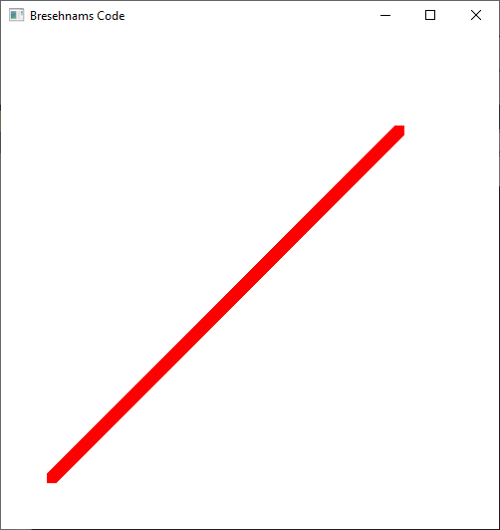

BDL(150, 150, 350, 350);

